# Assignment No:6

Practical Exercise: Basic Search Strategies – 8-Queens Problem

## 1) Problem Statement

Implement basic search strategies to solve the 8-Queens problem. The problem is to place 8 queens on a chessboard such that no two queens threaten each other. In other words, no two queens can share the same row, column, or diagonal.

## 2) Libraries Used

Python:  
1. **Basic Python Data Structures**: Lists are used to represent the chessboard and manipulate game states.

## 3) Theory

The 8-Queens problem is a constraint satisfaction problem where the goal is to place 8 queens on a chessboard such that no two queens can attack each other. A queen can attack any piece that is in the same row, column, or diagonal. The problem can be solved using backtracking, a search strategy that incrementally builds solutions and abandons a path as soon as it determines that the path will not lead to a solution.  
  
The algorithm places a queen in a column, then recursively places queens in subsequent columns, ensuring that each placement is safe. If placing a queen leads to a conflict, the algorithm backtracks and tries a different position.

## 4) Methods

1. **Board Representation**: The chessboard is represented as an 8x8 grid where 0 indicates an empty cell and 1 indicates a queen.  
2. **isSafe Function**: This function checks whether placing a queen in a particular row and column is safe by ensuring that no other queen exists in the same row, column, or diagonal.  
3. **solveNQueens Function**: This function attempts to place queens column by column. It uses recursion and backtracking to explore possible placements and backtracks when no valid placement is found.  
4. **Backtracking**: The algorithm explores one solution path at a time, and if it encounters a conflict, it backtracks to a previous step and tries a different path.

## 5) Advantages and Disadvantages

- **Advantages**: The backtracking algorithm efficiently explores the solution space by abandoning paths that cannot lead to a valid solution. It reduces the number of possible board configurations that need to be evaluated.  
- **Disadvantages**: Backtracking can be slow for larger problems, as it explores each possible move in a depth-first manner. For problems with large search spaces, optimization techniques may be required to improve performance.

## 6) Diagram

## Genetic Algorithm: 8 Queens Problem ...

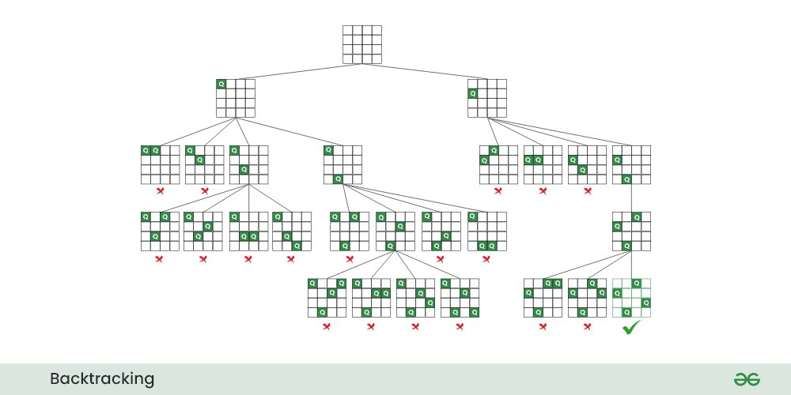

## 7) Conclusion

The 8-Queens problem demonstrates the effectiveness of search strategies like backtracking in solving constraint satisfaction problems. By incrementally placing queens and checking for conflicts, the algorithm ensures that a valid solution is found. While backtracking is an efficient solution for smaller problems like the 8-Queens, larger problems may require more advanced techniques to manage the search space.